**Software Requirements**

**Specification**

**for**

**OTC Drug Recommendation**

**Chatbot**

|  |
| --- |
| Version 1.0  Prepared by:  Shayan Ur Rehman 1712172  Esa Anjum 1712143  BSCS Section 7B  SZABIST University  November 2020 |

***Copyright © 2020-21 by OTC Drug Recommendation Chatbot. Permission is granted to use, modify, and distribute this document.***

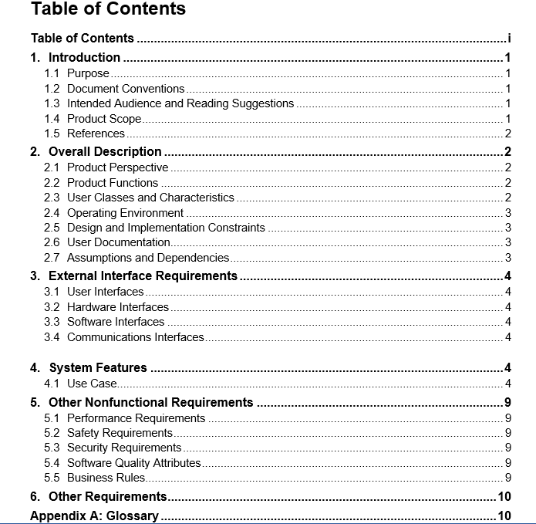

# Introduction

## Purpose

The Purpose of this Software Requirement Specification document is to build an AI powered OTC Drug Recommendation Chatbot to provide medicine recommendation and disease identification that minimizes the need to go to the doctor for Over-The-Counter Drugs, assisting patients and pharmacists.

## Document Conventions

This Document was created based on the IEEE template for System Requirement Specification Documents.

## Intended Audience and Reading Suggestions

* This project is intended for patients and pharmacists.

## Product Scope

The goal of OTC Drug Recommendation Chatbot is to provide interactive medicine recommendation that minimizes the need to go to the doctor for Over-The-Counter Drugs, assisting patients and pharmacists. Users will input any queries related to disease, the system will process it and then recommend the best OTC medicine name along with some of its details like drug name and interactions. It is to be noted that this will only be used for mild to moderate symptoms, anything severe or chronic will not be dealt with.

## References

“Designing an over the counter consumer decision-making tool for older adults”. DOI: https://doi.org/10.1016/j.jbi.2015.07.006. https://www.sciencedirect.com/science/article/pii/S153204641500146X/

# Overall Description

## Product Perspective

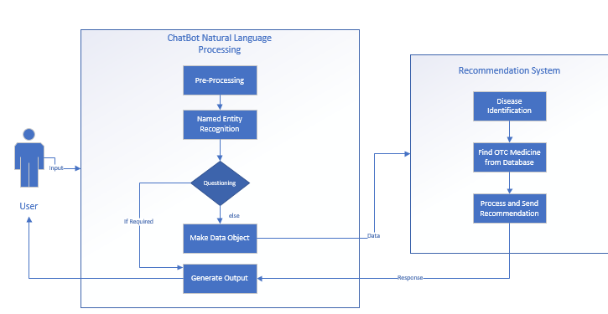WORKING OF CHATBOT

## Product Functions

* **Q/A based interaction** with chatbot to recommend best suitable medicine recommendation which doesn’t interact (react) with current medication and exacerbate underlying conditions.
* **Natural Language Processing**: ​The system will take in symptoms written
* in standard English.
* **Natural Language Responses**: ​The answer to the question will be
* written in standard and understandable English.
* **Information Extraction**: ​There will be a database containing all the
* information needed, populated using information extraction techniques.
* **Disease identification** through programming logic and Decision Tree algorithm.
* **Drug searching**: Search drugs and their relevant information.

## User Classes and Characteristics

Patient:

* Interact with chatbot to get medicine recommendation and disease identification
* Search Drugs and their relevant information

## Operating Environment

* + - * + Mac OS X
        + Windows 7
        + Windows 8
        + Windows 10

## Design and Implementation Constraints

**1.4.1 Limited Question Scope**

OTC Drug Recommendation chatbot is a rule-based chatbot, so the system will only be able to follow a certain pattern of Question and Answers.

## User Documentation

SRS, STD, and SDS documentation will be provided.

## Assumptions and Dependencies

We assume that all the users of the chatbot to know English language and very basic knowledge about interacting with websites. In addition to that, we also assume that there are no software/hardware errors or hardware requirement issues in the system in which the program has to be run and users have an active internet connection and have no other third-party application running that can cause problems.

We have used Spacy for NLP and Scikit-learn for Decision Tree algorithm training and prediction.

# External Interface Requirements

## User Interfaces

For this project we use “React Library” for frontend. In this project we have simple textboxes, buttons, labels and dropdown list and many other conventional UI components.



## Hardware Interfaces

As mentioned earlier, the project is an online web-based chatbot so a working internet connection is required and in order to interact with this app user must use keyboard and mouse to deal with the operations.

## Software Interfaces

PyCharm and SQLite Studio is utilized to build this web application. Python is the main language of the project.

## Communication Interfaces

The communication architecture will be a client-server model. Communication

between the client and server will be via Flask REST-compliant web service and

served over HTTP Secure (HTTPS). Format of the data between client and server will be in JSON.

# System Features

## Use Case

### Open Chat

|  |  |
| --- | --- |
| User Action | System Response |
| 1. User enters the chat room. | Chatbot greets. |
| 1. User replies. | Asks to describe symptoms. |
| Alternate Path: | N/A |
| Post-Condition: | User will be asked to describe symptoms. |
| Author Name: | Shayan Ur Rehman Siddiqui |

### Enter symptoms and details

|  |  |
| --- | --- |
| User Action | System Response |
| 1. User describes symptoms. | Chatbot stores symptoms, asks relevant questions (one by one). |
| 1. User replies to different questions. | Finds disease that matches user’s details, finds appropriate medicine, then recommends it. |
| Post-Condition: | System successfully identifies disease and recommends medicine. |
| Author: | Esa Anjum |

Alternate Path 1:

|  |  |
| --- | --- |
| User Action | System Response |
| 1A1) If User enters irrelevant information. | Chatbot asks user to reply again. |
| 1A2) User replies. | Conversation proceeds |

Alternate Path 2A:

|  |  |
| --- | --- |
| User Action | System Response |
| 2A1) If User enters symptoms that are severe or do not match any disease. | System recommends medicine to treat individual symptoms and a visit to doctor. |

Alternate Path 2B:

|  |  |
| --- | --- |
| User Action | System Response |
| 2B1) If User enters symptoms and details that do not match any appropriate medicine. | System notifies and recommends a visit to doctor. |

### Search Medicine Details

|  |  |
| --- | --- |
| User Action | System Response |
| 1. User enters details in different fields available and presses enter. | System searches for drugs related to that information and returns relevant drug(s)’ details. |
| Post-Condition: | System returns drug(s)’ information. |
| Author Name: | Shayan-Ur-Rehman Siddiqui |

Alternate Path:

|  |  |
| --- | --- |
| User Action | System Response |
| 1. If User enters irrelevant information. | System returns no results. |

# Other Nonfunctional Requirements

## Performance Requirements

This software requires a system with at least a 1.2 Gigahertz CPU, 2 gigabytes of RAM, OPENGL 2.0 compatible graphics card and browser with HTML5 support.

## Safety Requirements

There are no safety requirements as using this application is completely safe and it is made for every user that knows how to interact with websites.

## Security Requirements

Since this program is designed to manage medical data, all users especially administrators are required to keep their information strictly confidential and use a strong password as their personal data can be compromised and manipulated for wrong purposes.

## Software Quality Attributes

OTC Drug Recommendation Chatbot is programmed to be the easiest and the most efficient system that any user can access and use with ease and effectiveness. The whole program is designed to be as aesthetic and attractive as possible and easier to use with simple yet effective features.

# Other Requirements

**Appendix A: Glossary**

OTC: Over-the-counter **medicine** is also known as **OTC** or **nonprescription medicine**. All these terms refer to **medicine** that you can buy without a prescription.

NLP: Natural Language Processing

AI: Artificial Intelligence

ML: Machine Learning

HTTP: Hypertext Transfer Protocol

JSON: JavaScript Object Notation

**Appendix B: Analysis Models**

Not Applicable

**Appendix C: To Be Determined List**

Not Applicable